**CODING OF PRJECT GYM MANAGEMENT SYSTEM**

#include<iostream>

#include<string>

using namespace std;

struct joining {

string first_name;

string phone_no;

string address;

float price;

string Last_name;

};

int main() {

string y;

do {

system("cls");

cout << "\n\n\n\t\t\t=======================================================================";

cout << "\n\t\t\t\tGood Morining and Welcome to the GYM Management System\n";

cout << "\t\t\t=======================================================================";

cout << " \n\n\t\t\tHow May I help you Mam or Sir ? " << endl;

cout << " \n\t\t\t\tPress 1 for Information " << endl;

cout << " \n\t\t\t\tPress 2 for Joining " << endl;

cout << "\n\t\t\t\tPress 3 for Exit " << endl;

int a;

cout << "\n\t\t\tEnter your Choice ? ";

cin >> a;

system("cls");

joining j[1];

string c, e, f;

system("cls");

switch (a) {

case 1: cout << "\n\n\n\t\t\t=====================================================";

cout << "\n\t\t\t\tFor Information it is the procedure" << endl;

cout << "\t\t\t=====================================================" << endl;

cout << " \n\t\t\t\tMonthly charges for only GYM is Rs 1000 " << endl;

cout << " \n\t\t\t\tMonthly charges for GYM and Fitness is Rs 1500 " << endl;

cout << " \n\t\t\t\tMonthly charges for only Fitness is Rs 1000 " << endl;

cout << " \n\t\t\t\tThank You have a good-day " << endl;

cout << " \n\t\t\t\tYou may Leave Now " << endl;

cout << " \n\t\t\tDo you want to continue Yes or No ? ";

cin >> y;

cout << "\n\t\t\t\t\tOk Good-Bye " << endl;

break;

case 2: cout << "\n\n\n\t\t\t=================================================================";

cout << "\n\t\t\t\tFor Joining you need to fill the following form" << endl;

cout << "\t\t\t=================================================================" << endl;

for (int i = 0; i < 1; i++) {

int b;

cout << "\n\t\t\t\tEnter your First Name ? ";

cin >> j[i].first_name;

cout << "\n\t\t\t\tEnter your Last Name ? ";

cin >> j[i].Last_name;

cout << "\n\t\t\t\tEnter your Phone Number ? ";

cin >> j[i].phone_no;

cout << "\n\t\t\t\tEnter your Address ? ";

cin >> j[i].address;

cout << "\n\t\t\t\t\tPress 1 for only GYM " << endl;

cout << "\n\t\t\t\t\tPress 2 for GYM and Fitness " << endl;

cout << "\n\t\t\t\t\tPress 3 for only Fitness " << endl;

cout << "\n\t\t\t\tEnter your Choice ? ";

cin >> b;

system("cls");

switch (b) {

case 1: cout << "\n\n\n\t\t\t=====================================================================";

cout << "\n\t\t\t\t\tMonthly charges for only GYM is Rs 1000 " << endl;

cout << "\t\t\t=====================================================================" << endl;

cout << "\n\t\t\t\tDo you want to continue Yes or No ? ";

cin >> y;

if (y == "no") {

cout << "\n\t\t\t\t\t\tOk Good-Bye " << endl;

exit(0);

}

break;

case 2: cout << "\n\n\n\t\t\t=====================================================================";

cout << "\n\t\t\t\t\tMonthly charges for GYM and Fitness is Rs 1500" << endl;

cout << "\t\t\t=====================================================================" << endl;

cout << "\n\t\t\tDo you want to continue Yes or No ? ";

cin >> y;

if (y == "no") {

cout << "\n\t\t\t\t\tOk Good-Bye " << endl;

exit(0);

}

break;

case 3: cout << "\n\n\n\t\t\t=====================================================================";

cout << "\n\t\t\t\t\tMonthly charges for only Fitness is Rs 1000 " << endl;

cout << "\t\t\t=====================================================================" << endl;

cout << "\n\t\t\tDo you want to continue Yes or No ? ";

cin >> y;

if (y == "no") {

cout << "\n\t\t\t\t\tOk Good-Bye " << endl;

exit(0);

}

break;

default: cout << "\n\n\n\t\t\t=====================================================================";

cout << "\n\t\t\t\t\t\tYou enter wrong Number" << endl;

cout << "\t\t\t=====================================================================" << endl;

cout << "\n\t\t\tDo you want to continue Yes or No ? ";

cin >> y;

if (y == "no") {

cout << "\n\t\t\t\t\tOk Good-Bye " << endl;

exit(0);

}

break;

}

}

for (int i = 0; i < 1; i++) {

int d;

cout << "\n\t\t\tYour First Name is " << endl;

cout << "\t\t\t" << j[i].first_name << endl;

cout << "\n\t\t\tYour Last Name is " << endl;

cout << "\t\t\t" << j[i].Last_name << endl;

cout << "\n\t\t\tYour Phone Number is " << endl;

cout << "\t\t\t" << j[i].phone_no << endl;

cout << "\n\t\t\tYour Address is " << endl;

cout << "\t\t\t" << j[i].address << endl;

cout << "\n\t\t\tYour Package is " << endl;

cout << "\n\t\t\t\tPackage 1 GYM ? " << endl;

cout << "\n\t\t\t\tPackage 2 GYM and Fitness? " << endl;

cout << "\n\t\t\t\tPackage 3 Fitness? " << endl;

cout << "\n\t\t\tYour Package in word is ? ";

cin >> f;

cout << "\n\t\t\tYour Package in Number is ? ";

cin >> d;

system("cls");

switch (d) {

case 1:cout << "\n\n\n\t\t\t=====================================================================";

cout << "\n\t\t\t\t\t\tYour Package is only GYM " << endl;

cout << "\t\t\t=====================================================================" << endl;

cout << "\n\t\t\t\tYour price is Rs 1000 " << endl;

cout << "\n\t\t\tDo you want to continue Yes or No ? ";

cin >> y;

if (y == "no") {

cout << "\n\t\t\t\t\tOk Good-Bye " << endl;

exit(0);

}

break;

case 2:cout << "\n\n\n\t\t\t=====================================================================";

cout << "\n\t\t\t\t\t\tYour Package is both GYM and Fitness " << endl;

cout << "\t\t\t=====================================================================" << endl;

cout << "\n\t\t\t\tYour price is Rs 1500 " << endl;

cout << "\n\t\t\tDo you want to continue Yes or No ? ";

cin >> y;

if (y == "no") {

cout << "\n\t\t\t\t\tOk Good-Bye " << endl;

exit(0);

}

break;

case 3:cout << "\n\n\n\t\t\t=====================================================================";

cout << "\n\t\t\t\t\t\tYour Package is only Fitness" << endl;

cout << "\t\t\t=====================================================================" << endl;

cout << " \n\t\t\t\tYour price is Rs 1000 " << endl;

cout << "\n\t\t\tDo you want to continue Yes or No ? ";

cin >> y;

if (y == "no") {

cout << "\n\t\t\t\t\tOk Good-Bye " << endl;

exit(0);

}

break;

default:cout << "\n\n\n\t\t\t=====================================================================";

cout << "\n\t\t\t\t\t\tYou enter wrong Number" << endl;

cout << "\t\t\t=====================================================================" << endl;

cout << "\n\t\t\tDo you want to continue Yes or No ? ";

cin >> y;

if (y == "no") {

cout << "\n\t\t\t\t\tOk Good-Bye " << endl;

exit(0);

}

break;

}

cout << "\n\t\t\tEnter your Price ? ";

cin >> j[i].price;

cout << "\n\t\t\tYour Price is " << j[i].price << endl;

cout << "\n\t\t\tYou may Join from Now or from Towmarrow " << endl;

cout << "\n\t\t\tThank You and have a Good-day " << endl;

cout << "\n\t\t\tDo you want to continue Yes or No ? ";

cin >> y;

cout << "\n\t\t\t\t\tOk Good-Bye " << endl;

}

break;

case 3: cout << "\n\n\n\t\t\t=====================================================";

cout << "\n\t\t\t\tThank You and have a Good - day " << endl;

cout << "\t\t\t=====================================================" << endl;

cout << " \n\t\t\tYou may Leave Now " << endl;

cout << " \n\t\t\tDo you want to continue Yes or No ? ";

cin >> y;

if (y == "no") {

cout << "\n\t\t\t\t\tOk Good-Bye " << endl;

exit(0);

}

break;

default:

cout << "\n\n\n\t\t\t=====================================================";

cout << "\n\t\t\t\t\tYou enter wrong Number " << endl;

cout << "\t\t\t=====================================================" << endl;

cout << " \n\t\t\tDo you want to continue Yes or No ? ";

cin >> y;

if (y == "no") {

cout << "\n\t\t\t\t\tOk Good-Bye " << endl;

exit(0);

}

break;

}

} while (y == "yes");

return 0;

}

**OUTPUTS:**

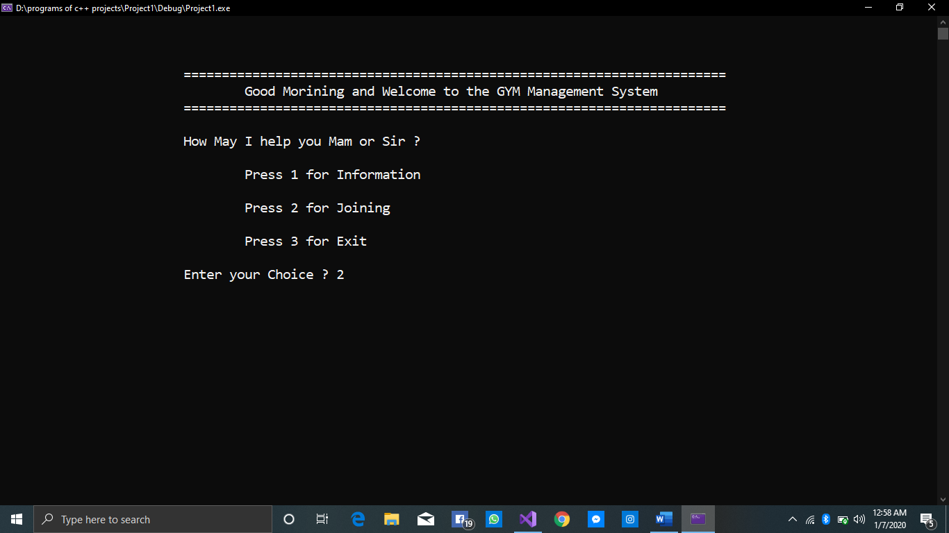

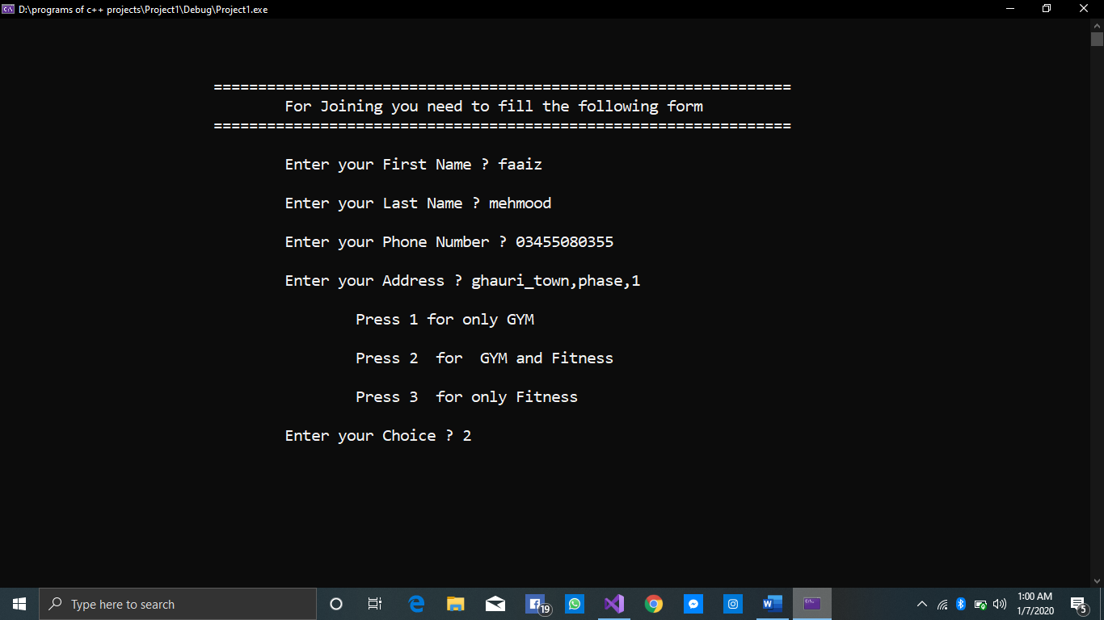

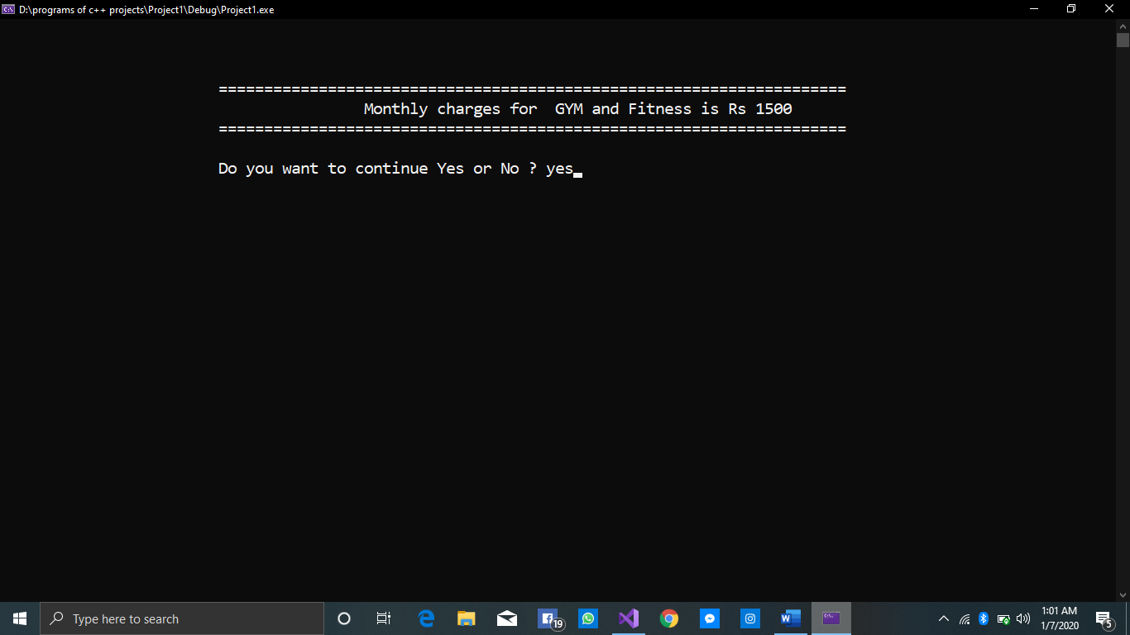

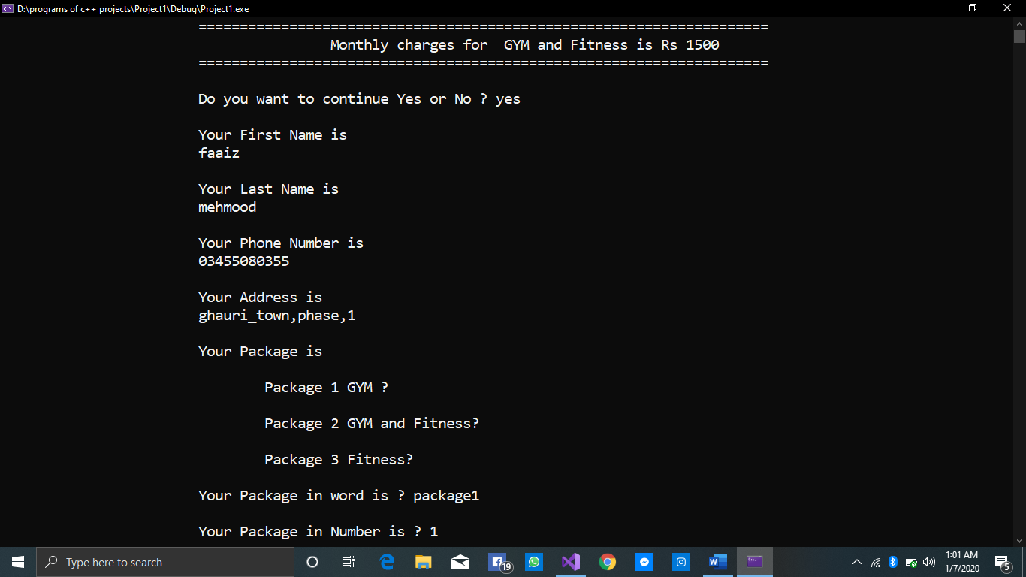

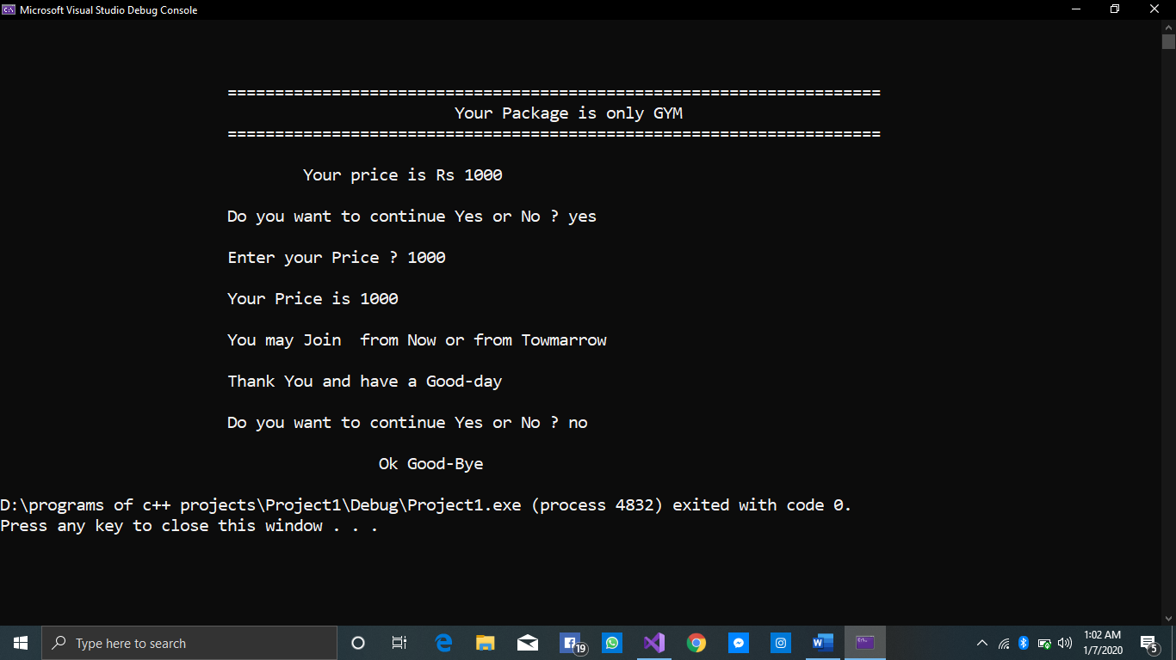

**THE END**